|  |
| --- |
| Answering Door Bell |
| **Using IR Receiver and an old remote control** |
| **By Aditya Khemka of D.B.M.S. English School, Jamshedpur (Jharkhand)** |

Answering Door Bell

(An assistive device for old aged people)

Using IR Receive and any old remote control

Calling Bells are common and used in almost every household in our society. As soon as the bell rings, we come to know that someone has come but very often it happens that we are busy with our house hold work or something else and due to some reason, cannot open the door immediately. This answering bell has a solution to this problem.

**Problem Statement**

This problem came up when respected Chairperson of our school Mrs. Bhanumati Neelkanthan spoke to us. She is 80 about years old. Chairpersons Comment:

**“Children when there is a knock at my door, I am unable to open the door immediately to attend my guest. Sometimes I am busy in work, sometimes I am in toilet and sometime I am unable to move fast since I have pain in my legs. Can you make a device with the help of which I can answer the person waiting? The answer such as ‘wait for five minutes’ or ‘I am busy etc.’** she added **“this will not only helpful to me but to lot of people who are in old age…………”**

This statement was enough for me to start thing and I started discussing with friends, family members, and aged people around me in my society. We were surprise to know that this was a problem faced by a lot of people.

I defined the problem **“To make a device which can answer to our guest knocking at the door if we are unable to open the door after the bell ring”**

**Solution**

**DESIGN CYCLE:**

**I: EMPATHIZE**

* Problem in old age to move fast
* Problem in answering people from washroom
* Problem of opening the door when busy

**II. DEFINE**

To make a device which can answer our guest knocking at the door if we are unable to open the door after the bell ring.

**III. IDEATE**

**Brain Storming**

* A doorbell made using AI
* Make an app to communicate with the guests
* Send SMS from mobile
* Make an device to display the message to the guest in the door with remote and IR Receiver

**Idea chosen after brain storming**

**Make an device to display the message to the guest in the door with remote and IR Receiver**

**Pre-requisite**

* Basic knowledge of Electronics circuits
* Basic knowledge of Arduino programming and a few other simple components.

**Material Required**

* IR Receiver (1838T)
* An old Remote (Here using Sony RMT-TX111P)
* Arduino UNO
* LCD display(20 x 2)
* A few Jumper Wires
* An RGB LED or a buzzer

**IV. PROTOTYPE:**

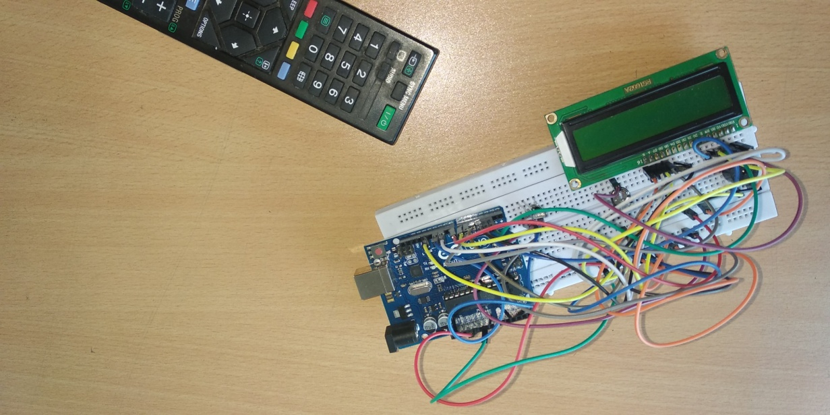

**(The first working prototype)**

**Connections**

**IR Receiver**

Vcc to 5V pin of Arduino

GND to Ground pin of Arduino

OUT to the pin 11 of Arduino.

**Buzzer/ RGB Connection**

Buzzer/ RGB Positive to Pin 13

Buzzer/ RGB Ground to GND

**LCD Connection**

Pin 1: VSS to GND of Arduino

Pin 2: VDD to 5V of Arduino

Pin 3: VO to potentiometer (centre pin)

Pin4: RS to Pin2 of Arduino

Pin5: RW to GND of Arduino

Pin6: EN to Pin3 of Arduino

Pin7: [Not used]

Pin8: [Not used]

Pin9: [Not used]

Pin10: [Not used]

Pin11: D4 to Pin4 of Arduino

Pin12: D5 to Pin5 of Arduino

Pin13: D6 to pin6 of Arduino

Pin14: D7 to Pin7 of Arduino

Pin15: A to 10 of Arduino

Pin16: K to GND of Arduino

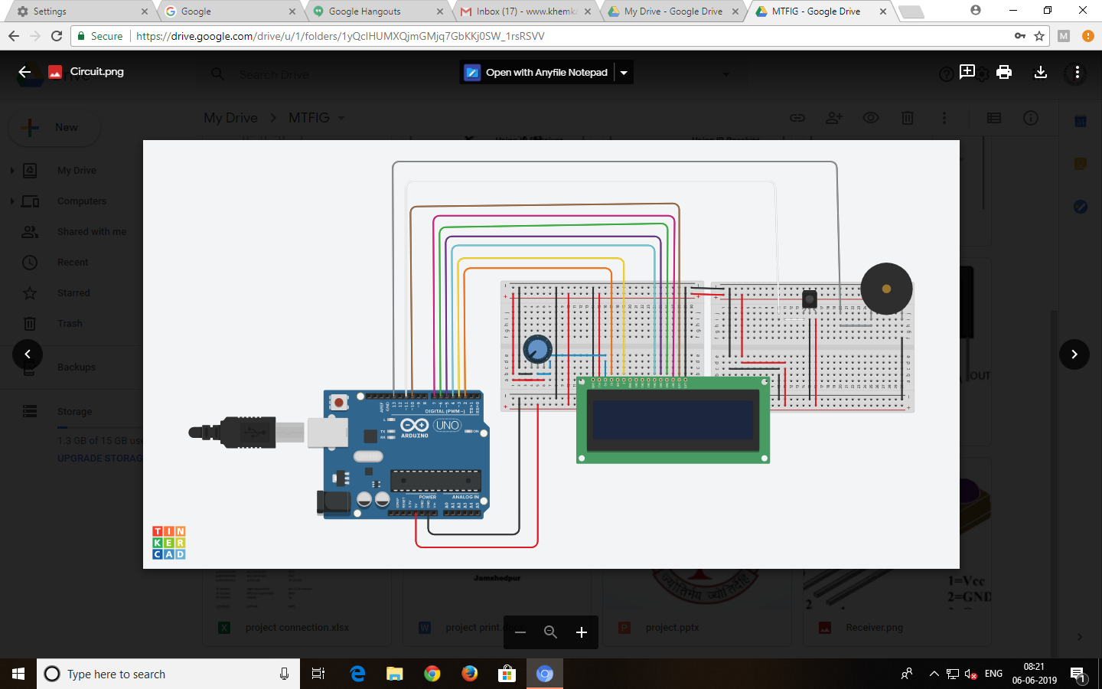

**(Visual circuit of the first Prototype)**

**Arduino Programming:**

**//initialization**

**#include <IRremote.h>**

**#include <IRremoteInt.h>**

**#include <LiquidCrystal.h>**

**int IRpin = 11;**

**IRrecv irrecv(IRpin);**

**decode_results results;**

**const int rs=2, e=3, d4=4, d5=5, d6=6, d7=7;**

**LiquidCrystal lcd(rs,e,d4,d5,d6,d7);**

**const int RGB=13, led=8, bl=10;**

**//setup**

**void setup() {**

**lcd.begin(16,2);**

**lcd.clear();**

**Serial.begin(9600);**

**pinMode(RGB,OUTPUT);**

**pinMode(led,OUTPUT);**

**pinMode(bl,OUTPUT);**

**irrecv.enableIRIn(); // Start the receiver**

**lcd.clear();**

**digitalWrite(RGB,LOW);**

**digitalWrite(led,LOW);**

**digitalWrite(bl,HIGH);**

**lcd.setCursor(0,0);**

**lcd.print("D.B.M.S. English");**

**lcd.setCursor(0,1);**

**lcd.print(" School ");**

**}**

**//working**

**void loop() {**

**if (irrecv.decode(&results)){ //checks if signal is transmitted**

**Serial.println(results.value); // prints the value of the hex code on the serial monitor**

**//print message on L.C.D. according to the value received**

**if(results.value==2672){**

**lcd.clear();**

**digitalWrite(RGB,LOW);**

**digitalWrite(led,LOW);**

**digitalWrite(bl,HIGH);**

**lcd.setCursor(0,0);**

**lcd.print(" B.H. Area ");**

**lcd.setCursor(0,1);**

**lcd.print(" Road No. 7 ");**

**}**

**if(results.value==2704){**

**lcd.clear();**

**digitalWrite(RGB,LOW);**

**digitalWrite(led,LOW);**

**digitalWrite(bl, LOW);**

**lcd.setCursor(0,0);**

**lcd.print(" ");**

**lcd.setCursor(0,1);**

**lcd.print(" ");**

**}**

**if(results.value==16){**

**lcd.clear();**

**digitalWrite(led,HIGH);**

**digitalWrite(bl,HIGH);**

**lcd.setCursor(0,0);**

**lcd.print("Please wait for ");**

**lcd.setCursor(0,1);**

**lcd.print(" a minute ");**

**digitalWrite(RGB,HIGH);**

**delay(500);**

**digitalWrite(RGB,LOW);**

**delay(100);**

**digitalWrite(RGB,HIGH);**

**delay(50);**

**digitalWrite(RGB,LOW);**

**delay(50);**

**digitalWrite(RGB,HIGH);**

**delay(50);**

**digitalWrite(RGB,LOW);**

**delay(50);**

**digitalWrite(RGB,HIGH);**

**delay(250);**

**digitalWrite(RGB,LOW);**

**digitalWrite(led,LOW);**

**}**

**if(results.value==2064){**

**lcd.clear();**

**digitalWrite(led,HIGH);**

**digitalWrite(bl,HIGH);**

**lcd.setCursor(0,0);**

**lcd.print(" Please ");**

**lcd.setCursor(0,1);**

**lcd.print(" Come in ");**

**digitalWrite(RGB,HIGH);**

**delay(500);**

**digitalWrite(RGB,LOW);**

**delay(100);**

**digitalWrite(RGB,HIGH);**

**delay(50);**

**digitalWrite(RGB,LOW);**

**delay(50);**

**digitalWrite(RGB,HIGH);**

**delay(50);**

**digitalWrite(RGB,LOW);**

**delay(50);**

**digitalWrite(RGB,HIGH);**

**delay(250);**

**digitalWrite(RGB,LOW);**

**digitalWrite(led,LOW);**

**}**

**if(results.value==1040){**

**lcd.clear();**

**digitalWrite(led,HIGH);**

**digitalWrite(bl,HIGH);**

**lcd.setCursor(0,0);**

**lcd.print(" Just ");**

**lcd.setCursor(0,1);**

**lcd.print(" coming ");**

**digitalWrite(RGB,HIGH);**

**delay(500);**

**digitalWrite(RGB,LOW);**

**delay(100);**

**digitalWrite(RGB,HIGH);**

**delay(50);**

**digitalWrite(RGB,LOW);**

**delay(50);**

**digitalWrite(RGB,HIGH);**

**delay(50);**

**digitalWrite(RGB,LOW);**

**delay(50);**

**digitalWrite(RGB,HIGH);**

**delay(250);**

**digitalWrite(RGB,LOW);**

**digitalWrite(led,LOW);**

**}**

**if(results.value==528){**

**lcd.clear();**

**digitalWrite(led,HIGH);**

**digitalWrite(bl,HIGH);**

**lcd.setCursor(0,0);**

**lcd.print("Please wait for ");**

**lcd.setCursor(0,1);**

**lcd.print(" 5 minutes ");**

**digitalWrite(RGB,HIGH);**

**delay(500);**

**digitalWrite(RGB,LOW);**

**delay(100);**

**digitalWrite(RGB,HIGH);**

**delay(50);**

**digitalWrite(RGB,LOW);**

**delay(50);**

**digitalWrite(RGB,HIGH);**

**delay(50);**

**digitalWrite(RGB,LOW);**

**delay(50);**

**digitalWrite(RGB,HIGH);**

**delay(250);**

**digitalWrite(RGB,LOW);**

**digitalWrite(led,LOW);**

**}**

**if(results.value==3088){**

**lcd.clear();**

**digitalWrite(led,HIGH);**

**digitalWrite(bl,HIGH);**

**lcd.setCursor(0,0);**

**lcd.print(" Please drop it ");**

**lcd.setCursor(0,1);**

**lcd.print(" in the mailbox ");**

**digitalWrite(RGB,HIGH);**

**delay(500);**

**digitalWrite(RGB,LOW);**

**delay(100);**

**digitalWrite(RGB,HIGH);**

**delay(50);**

**digitalWrite(RGB,LOW);**

**delay(50);**

**digitalWrite(RGB,HIGH);**

**delay(50);**

**digitalWrite(RGB,LOW);**

**delay(50);**

**digitalWrite(RGB,HIGH);**

**delay(250);**

**digitalWrite(RGB,LOW);**

**digitalWrite(led,LOW);**

**}**

**if(results.value==2576){**

**lcd.clear();**

**digitalWrite(led,HIGH);**

**digitalWrite(bl,HIGH);**

**lcd.setCursor(0,0);**

**lcd.print(" Can we meet ");**

**lcd.setCursor(0,1);**

**lcd.print(" Later? ");**

**digitalWrite(RGB,HIGH);**

**delay(500);**

**digitalWrite(RGB,LOW);**

**delay(100);**

**digitalWrite(RGB,HIGH);**

**delay(50);**

**digitalWrite(RGB,LOW);**

**delay(50);**

**digitalWrite(RGB,HIGH);**

**delay(50);**

**digitalWrite(RGB,LOW);**

**delay(50);**

**digitalWrite(RGB,HIGH);**

**delay(250);**

**digitalWrite(RGB,LOW);**

**digitalWrite(led,LOW);**

**}**

**if(results.value==1552){**

**lcd.clear();**

**digitalWrite(led,HIGH);**

**digitalWrite(bl,HIGH);**

**lcd.setCursor(0,0);**

**lcd.print(" Can we meet ");**

**lcd.setCursor(0,1);**

**lcd.print(" tomorrow ");**

**digitalWrite(RGB,HIGH);**

**delay(500);**

**digitalWrite(RGB,LOW);**

**delay(100);**

**digitalWrite(RGB,HIGH);**

**delay(50);**

**digitalWrite(RGB,LOW);**

**delay(50);**

**digitalWrite(RGB,HIGH);**

**delay(50);**

**digitalWrite(RGB,LOW);**

**delay(50);**

**digitalWrite(RGB,HIGH);**

**delay(250);**

**digitalWrite(RGB,LOW);**

**digitalWrite(led,LOW);**

**}**

**if(results.value==3600){**

**lcd.clear();**

**digitalWrite(led,HIGH);**

**digitalWrite(bl,HIGH);**

**lcd.setCursor(0,0);**

**lcd.print(" We will meet ");**

**lcd.setCursor(0,1);**

**lcd.print(" one hour later ");**

**digitalWrite(RGB,HIGH);**

**delay(500);**

**digitalWrite(RGB,LOW);**

**delay(100);**

**digitalWrite(RGB,HIGH);**

**delay(50);**

**digitalWrite(RGB,LOW);**

**delay(50);**

**digitalWrite(RGB,HIGH);**

**delay(50);**

**digitalWrite(RGB,LOW);**

**delay(50);**

**digitalWrite(RGB,HIGH);**

**delay(250);**

**digitalWrite(RGB,LOW);**

**digitalWrite(led,LOW);**

**}**

**if(results.value==272){**

**lcd.clear();**

**digitalWrite(led,HIGH);**

**digitalWrite(bl,HIGH);**

**lcd.setCursor(0,0);**

**lcd.print(" Meet you ");**

**lcd.setCursor(0,1);**

**lcd.print(" there. ");**

**digitalWrite(RGB,HIGH);**

**delay(500);**

**digitalWrite(RGB,LOW);**

**delay(100);**

**digitalWrite(RGB,HIGH);**

**delay(50);**

**digitalWrite(RGB,LOW);**

**delay(50);**

**digitalWrite(RGB,HIGH);**

**delay(50);**

**digitalWrite(RGB,LOW);**

**delay(50);**

**digitalWrite(RGB,HIGH);**

**delay(250);**

**digitalWrite(RGB,LOW);**

**digitalWrite(led,LOW);**

**}**

**if(results.value==2320){**

**lcd.clear();**

**digitalWrite(led,LOW);**

**digitalWrite(bl,HIGH);**

**digitalWrite(RGB,LOW);**

**lcd.setCursor(0,0);**

**lcd.print("D.B.M.S. English");**

**lcd.setCursor(0,1);**

**lcd.print(" School ");**

**}**

**delay(499);**

**irrecv.resume();**

**delay(499);**

**}//if any results received**

**}//void loop**

Block Diagram

V. TEST

After testing, the device was approved by our respected chairperson, Mrs. Bhanumati Neelkanthan to work properly and also commented that it was “**a perfect solution to her problem**”.

VI. Way Forward:

Currently I am working to send custom messages to the screen, with the help of Blynk Application (Blynk.cc) and also look ahead to install a camera…

Video Link: <https://www.youtube.com/watch?v=9-jtrJ58DsU>

(Video length: 1:29:55 minutes)